Sample exam

Q1

Q2

Q3

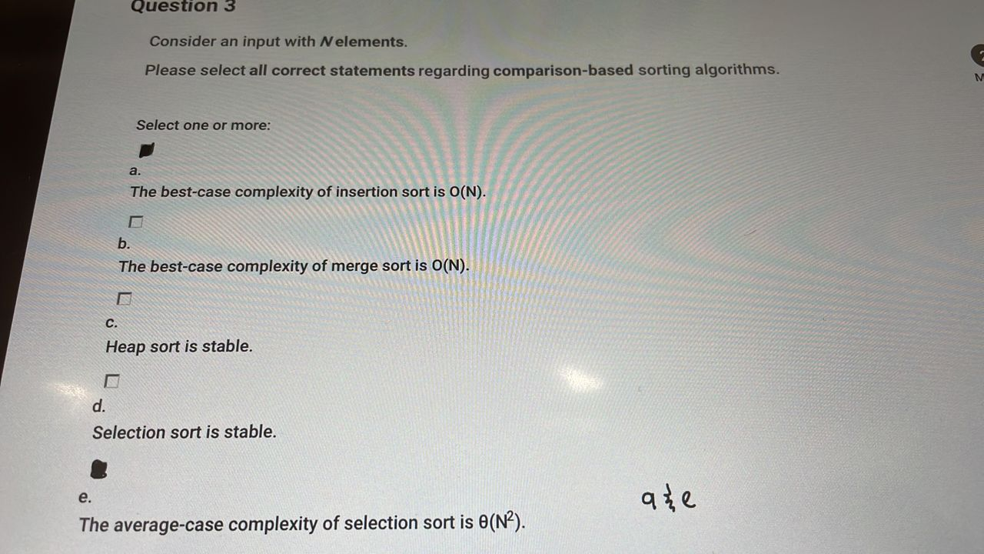

Q4

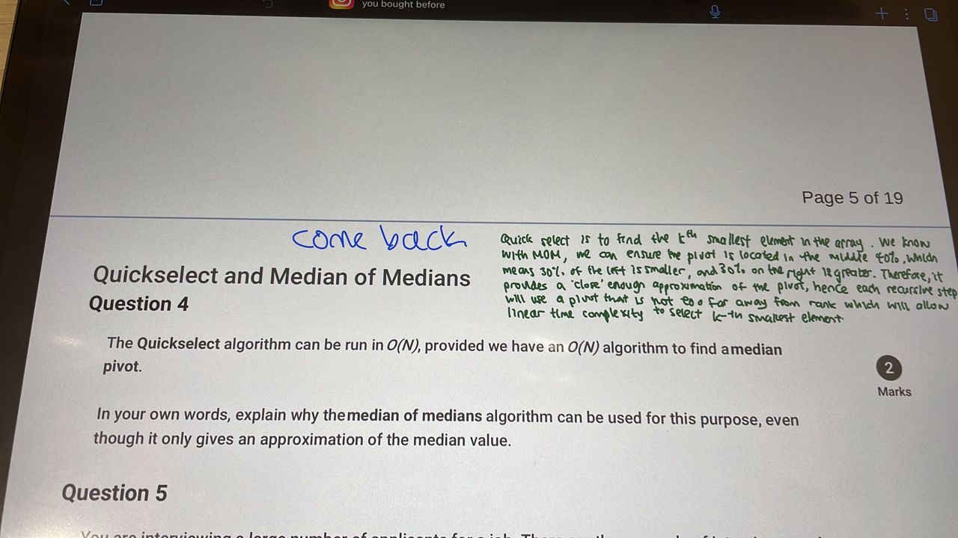

Median of medians – good enough median which the pivot in the middle 50 % area on the sorted array 1/(1-0.6) = 2.5

Array, the worst case of that area, is when the pivot is 75th percentile which can still reduce the array by 0.75 every iteration from the last array = 0.75N + 0.75*2N + 0.75*3N = 1/(1-0.75) < 4N geometric series the comparison is O(1). Since we can not expect every time

Spot on, expected 50% to be choosen as good enough pivot, we double our choose time

4N * 2 = 8N = O(N)

Q5

* Let k = n/2
* Use quickselect to select the kth largest item in the list.
* ranking is >= to that of array[k]

Quick select with that k

Then k = 0.2n, quick select again which would select top 20% with highest rank

Go the third round

Remaining go to the second round

Q6

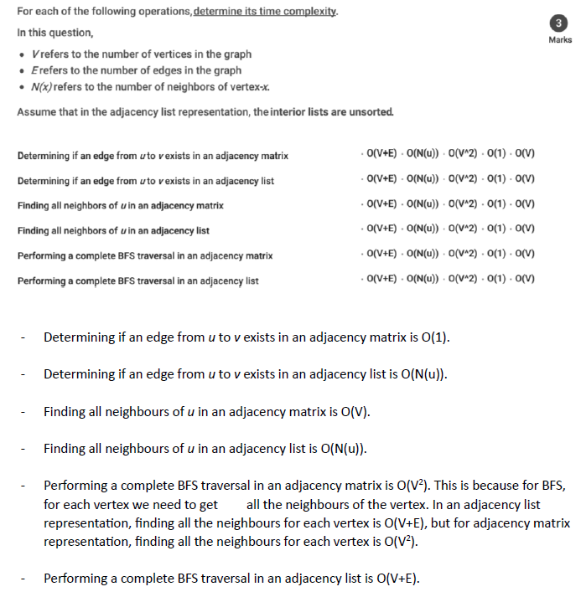

O(V^2) BFS in matrix would probably run through every vertex column for every vertex row

Q7

Break ties in ascending alphabetical order – if multiple options choose the one Lexi graphically smaller

DFS: once found one, just go straight into it (if v.visited == False next_dfs = self.def_self(v.id) , not need stack for checking discovered, see dfs_self function in bfs_dfs py file)

A -> B -> C -> D - > F - > E (no non-visited vertex), (backtrack to the vertex that has next_dfs by recursion D) -> H -> G

BFS

A is the root node, D is the leaf node, height of a tree is the number of edges from A to D: 3

Q8

Q9

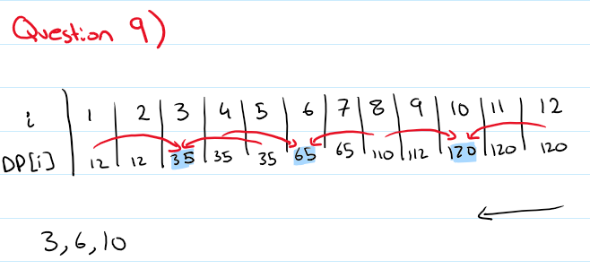

Q10

S 0

A -2

B -1

C -4

D -3  
E -5

F -4

Q11

Q12

new flow: 1

current flow(existent flow from c to t and from d to t: 3 + 3 = 6)

6 + 1= 7

Q13

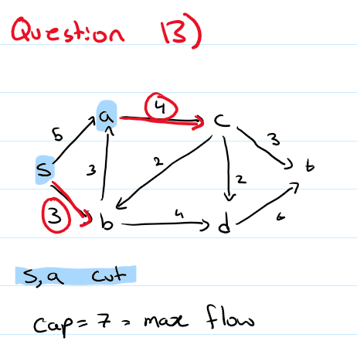

s,a before cut

everything else after cut

Q14

Q15

Q16

* D. Sorted array: logN to search for duplicate, O(N) time to insert in correct position
* B. Unsorted array: O(N) time to search for duplicate, O(1) time to insert (append)
* A. BST: O(N) time to search and insert in pathological case, not balanced tree

Q17

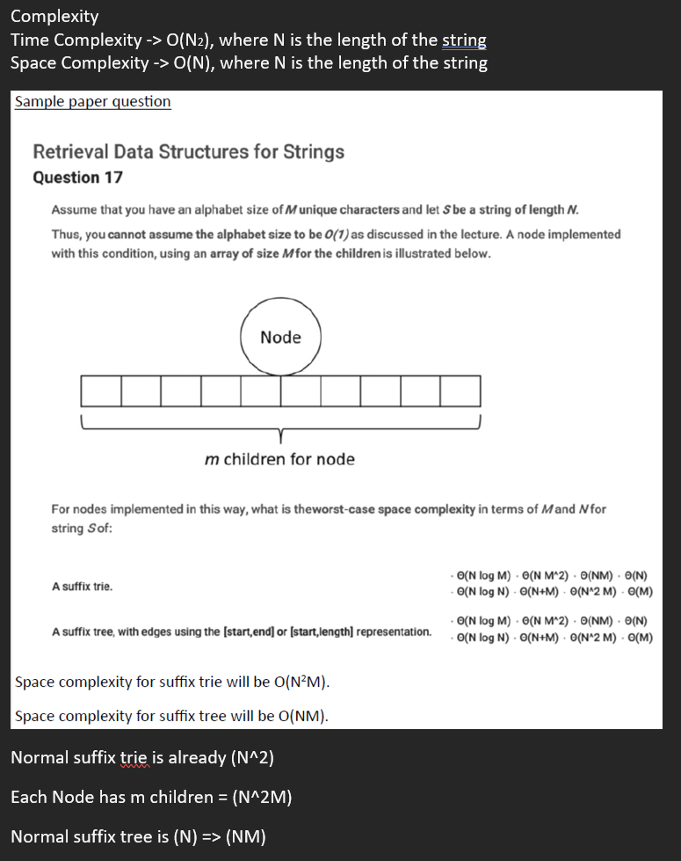

Q18

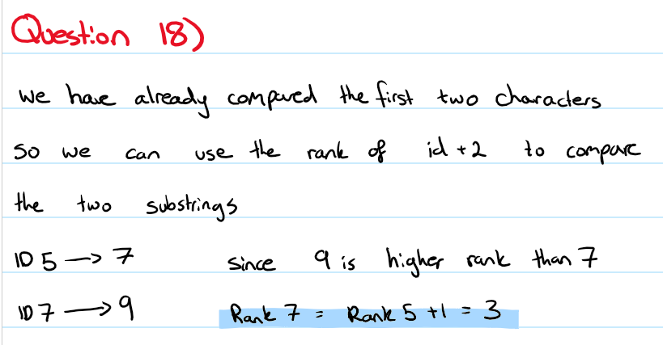

2k = 4 k =2

Q19

cities = nodes

roads = edges

2 destinations are in the same graph don't add" do you mean components? Aka avoiding cycles.

Q20

Q21

Create another flow network for left over student

Q22

